2019 QAP - Workforce Housing Communities Methodology
*Additional communities added using the most recent (2016) MN DEED data released
Communities with a need for workforce housing are identified using data on: (1) total jobs in 2015, (2) 5 year job growth, or (3) long distance commuting. Data on jobs and growth are from the Minnesota Department of Employment and Economic Development’s Quarterly Census of Employment and Wages. Data on commuting are from the US Census Bureau’s Longitudinal Employer-Household Dynamics program. Workforce housing areas are defined separately for the Twin Cities Metro (7 County) and Greater Minnesota. The priority has two point levels, 6 and 3 points. The following sections describe the eligible communities and buffers around these communities for the two regions. Applicants will find interactive maps to identify whether a property falls within these areas at Minnesota Housing’s website: www.mnhousing.gov > Policy & Research > Community Profiles.

6 Points
  - Top Job Centers. A community is eligible if it is one of the top 10 job centers in Greater Minnesota or the top 5 job centers in the Twin Cities Metro as of 2015 as defined by total jobs.
(OR)
  - Net Five Year Job Growth. Communities are eligible in Greater Minnesota if they have at least 2,000 jobs in the current year and had a net job growth of at least 100 jobs in the last five years. In the Twin Cities Metro the minimum net job growth is 500. Minnesota Housing is publishing in this document the most current available data from the Dept. of Employment and Economic Development, 2010-2015; but will add additional communities when more current data becomes available in April 2018 for the 2019 QAP.
(OR)
  - Individual Employer Growth. A community is eligible if an individual employer has added at least 100 net jobs (for permanent employees of the company) during the last five years, and can provide sufficient documentation signed by an authorized representative of the company to prove the growth.
(OR)
- 3 Points
  - Long Commute Communities. A community is eligible if it is not a top job center, job growth community, or an individual employer growth community, yet is identified as a long commute community. These are communities where 15% or more of the communities’ workforce travels 30+ miles into the community for work.

In each case above, communities are buffered by 10 miles in Greater Minnesota and 5 miles in the Twin Cities Metro to account for a modest commuteshed.
The maps and tables below and on following pages list and display eligible areas for the Twin Cities Metro (pages 2 and 3) and Greater Minnesota (pages 4 and 5). If additional communities become eligible in the next year with updated data, Minnesota Housing will add them to the 2019 QAP lists; no communities will be subtracted from the 2019 QAP lists with the updated.

Twin Cities Metro Job Centers and Ranked Job Growth Communities 2010-2015 (6 Points)
Twin Cities Metro Top 5 Job Centers (2015 or 2016) |  | Twin Cities Metro Communities With Net Growth of 500 Jobs or More (2010-2015 and 2011-2016)
Minneapolis, Hennepin |  | Andover, Anoka | Lino Lakes, Anoka
Saint Paul, Ramsey |  | Anoka, Anoka | Little Canada, Ramsey
Bloomington, Hennepin |  | Apple Valley, Dakota | Maple Grove, Hennepin
Eagan, Dakota |  | Blaine, largely Anoka | Maple Plain, Hennepin
Eden Prairie, Hennepin |  | Bloomington, Hennepin | Maplewood, Ramsey
 |  | Brooklyn Center, Hennepin | Medina, Hennepin
 |  | Brooklyn Park, Hennepin | Minneapolis, Hennepin
 |  | Burnsville, Dakota | Minnetonka, Hennepin
 |  | Chanhassen, largely Carver | New Brighton, Ramsey
 |  | Chaska, Carver | Oakdale, Washington
 |  | Coon Rapids, Anoka | Plymouth, Hennepin
 |  | Cottage Grove, Washington* | Ramsey, Anoka
 |  | Crystal, Hennepin* | Richfield, Hennepin
 |  | Eagan, Dakota | Rogers, Hennepin
 |  | Eden Prairie, Hennepin | Rosemount, Dakota
 |  | Edina, Hennepin | Roseville, Ramsey
 |  | Farmington, Dakota* | Saint Louis Park, Hennepin
 |  | Forest Lake, Washington* | Saint Paul, Ramsey
 |  | Fridley, Anoka | Savage, Scott
 |  | Ham Lake, Anoka | Shakopee, Scott
 |  | Hopkins, Hennepin | Vadnais Heights, Ramsey
 |  | Hugo, Washington | Waconia, Carver
 |  | Inver Grove Heights, Dakota | White Bear Lake, Ramsey
 |  | Lake Elmo, Washington | Woodbury, Washington
 |  | Lakeville, Dakota

Source: Minnesota Housing analysis of Minnesota Dept. of Employment and Economic Development Quarterly Census of Employment and Wages (2010-2015). *Community added based on 2011-2016 net job growth.

Twin Cities Metro Long Commute Communities (3 Points)
Twin Cities Metro Long Commute Communities
Belle Plaine | Falcon Heights | Rogers
Champlin | Hopkins | Rosemount
Chanhassen | Maplewood

Source: Minnesota Housing analysis of US Census Longitudinal Employer Household Dynamics Data, 2014 and 2015.
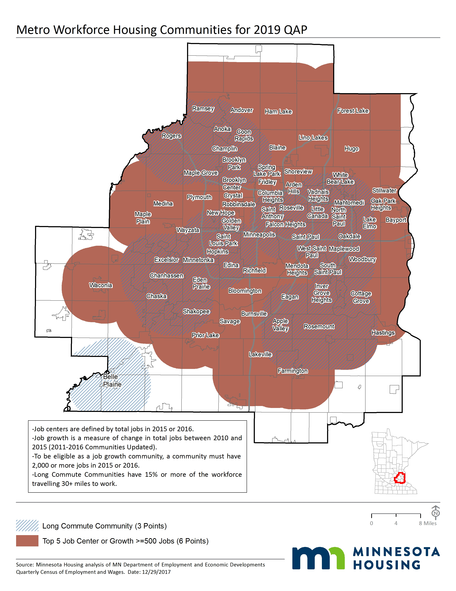

Greater Minnesota Job Centers and Job Growth Communities 2010-2015 (6 Points)
Greater Minnesota Top 10 Job Centers  (2015 or 2016) |  | Greater MN Communities With Net Growth of 100 jobs or more (2010-2015 and 2011-2016)
Rochester, Olmsted |  | Aitkin, Aitkin* | Monticello, Wright
Duluth, Saint Louis |  | Albertville, Wright | Moorhead, Clay*
Saint Cloud, largely Stearns |  | Alexandria, Douglas | Moose Lake, Carlton*
Mankato, largely Blue Earth |  | Austin, Mower | Mora, Kanabec*
Winona, Winona |  | Baxter, Crow Wing | Morris, Stevens
Owatonna, Steele |  | Becker, Sherburne | Mountain Iron, Saint Louis
Willmar, Kandiyohi |  | Bemidji, Beltrami | New Ulm, Brown
Moorhead, Clay |  | Big Lake, Sherburne | North Branch, Chisago
Austin, Mower |  | Brainerd, Crow Wing | North Mankato, Nicollet
Alexandria, Douglas |  | Buffalo, Wright* | Northfield, largely Rice
 |  | Cambridge, Isanti | Otsego, Wright
 |  | Cloquet, Carlton | Owatonna, Steele
 |  | Cold Spring, Stearns* | Park Rapids, Hubbard
 |  | Delano, Wright | Perham, Otter Tail
 |  | Detroit Lakes, Becker | Princeton, Mille Lacs
 |  | Dodge Center, Dodge | Redwood Falls, Redwood*
 |  | Duluth, Saint Louis | Rochester, Olmsted
 |  | East Grand Forks, Polk | Roseau, Roseau
 |  | Elk River, Sherburne | Saint Cloud, largely Stearns
 |  | Faribault, Rice | Saint James, Watonwan*
 |  | Glencoe, McLeod | Saint Joseph, Stearns*
 |  | Glenwood, Pope | Saint Michael, Wright
 |  | Grand Rapids, Itasca | Saint Peter, Nicollet
 |  | Hermantown, Saint Louis | Sartell, largely Stearns
 |  | Hibbing, Saint Louis | Sauk Rapids, Benton
 |  | Hutchinson, McLeod | Thief River Falls, Pennington
 |  | Lake City, Goodhue | Waite Park, Stearns
 |  | Le Sueur, largely Le Sueur | Warroad, Roseau*
 |  | Litchfield, Meeker | Willmar, Kandiyohi
 |  | Luverne, Rock | Willmar Twp., Kandiyohi*
 |  | Mankato, largely Blue Earth | Winona, Winona
 |  | Marshall, Lyon | Wyoming, Chisago
 |  | Melrose, Stearns

Source: Minnesota Housing analysis of Minnesota Dept. of Employment and Economic Development Quarterly Census of Employment and Wages (2010-2015). *Communities added based on 2016 data.

Greater Minnesota Long Commute Communities (3 Points)
Greater Minnesota Metro Long Commute Communities
Aitkin | Glencoe* | Moose Lake | Sauk Centre
Albert Lea | Goodview | Mora | Sauk Rapids*
Alexandria | Grand Rapids | Morris | St. Cloud*
Austin | Hermantown | Mountain Iron | St. James
Baxter | Hibbing | New Ulm | St. Joseph
Belgrade | Hinckley | New York Mills* | St. Michael
Bemidji | Hutchinson | North Branch | St. Peter
Big Lake* | International Falls | North Mankato* | Staples
Brainerd | Jackson* | Northfield | Thief River Falls
Caledonia | Kathio Twp. | Owatonna | Virginia
Cambridge | Lake City | Park Rapids | Wabasha
Cloquet | Litchfield* | Perham | Wadena
Crookston | Little Falls | Pike Bay Twp. | Waite Park*
Detroit Lakes | Luverne* | Pipestone | Warroad
Duluth* | Mankato* | Princeton | Willmar
East Grand Forks | Marshall | Red Wing | Willmar Twp.*
Elk River | Melrose | Redwood Falls | Windom
Fairmont | Montevideo | Rochester* | Winona
Faribault | Moorhead* | Roseau | Worthington
Fergus Falls

Source: Minnesota Housing analysis of US Census Longitudinal Employer Household Dynamics Data, 2014. *Communities added based on 2015 US Census Longitudinal Employer Household Dynamics Data.

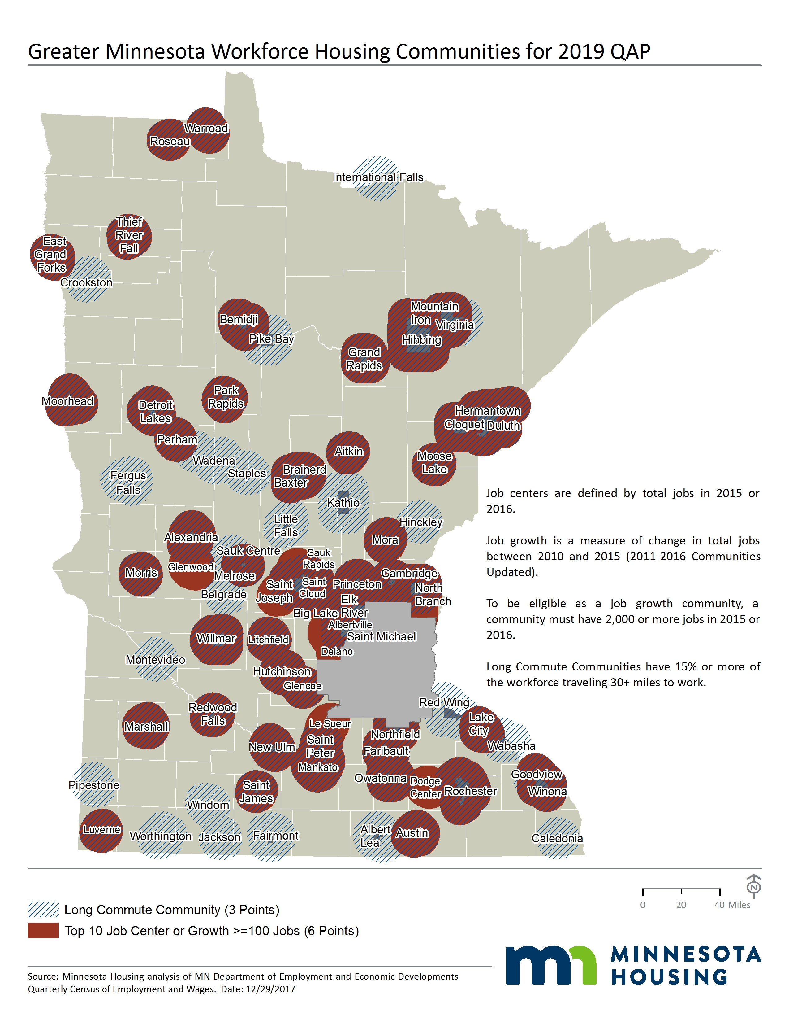

The 5 year job growth communities presented in this methodology are for 2010-2015. Minnesota Housing will also add eligible 2011-2016 growth communities by application release of the 2019 QAP. Data source: http://mn.gov/deed/data/data-tools/qcew.jsp
Data from LEHD are current to 2014. Minnesota Housing will also add eligible communities with more current data available by application release of the 2019 QAP. Data source: http://lehd.did.census.gov/data/.

