

# Multifamily Customer Portal

Special Claims

July 2024

## Contents

Overview 4

System Terminology 4

Navigation Menu 4

Access Properties 5

Create a Special Claims Packet 6

Create a Unit Special Claim 8

Edit or Delete a Special Claim 11

Edit a Special Claim 11

Delete a Special Claim 12

Upload Files 13

Drag and Drop 13

Use ‘Add Files’ Button 13

Manage Your Checklist 14

Submit a Special Claims Packet 15

Modify and Resubmit a Pending Unit Special Claim 18

Approved, Adjusted, or Denied Unit Special Claims Notifications 20

Approved or Adjusted Unit Special Claims 20

Denied Unit Special Claims 21

View Notifications 22

Access Special Claims Packet Notifications 22

Access Unit Special Claims Notifications 23

Check Claim Status 23

Check Unit Special Claim Status 25

System Support 25

## Overview

HUD Section 8 and Section 811 Project-based Rental Assistance owners and property agents must submit [Special Claims](https://mnhousing.gov/rental-housing/property-managers/section-8---811-contracts.html) to Minnesota Housing electronically using the Multifamily Customer Portal (Portal). This guide outlines the process to create, submit, and manage Special Claims.

New to the Portal? Refer to our [Multifamily Customer Portal Resources](https://mnhousing.gov/rental-housing/housing-development-and-capital-programs/portal.html) page to get started.

## System Terminology

This guide refers to Properties, Special Claim packets, and Unit Special Claims.

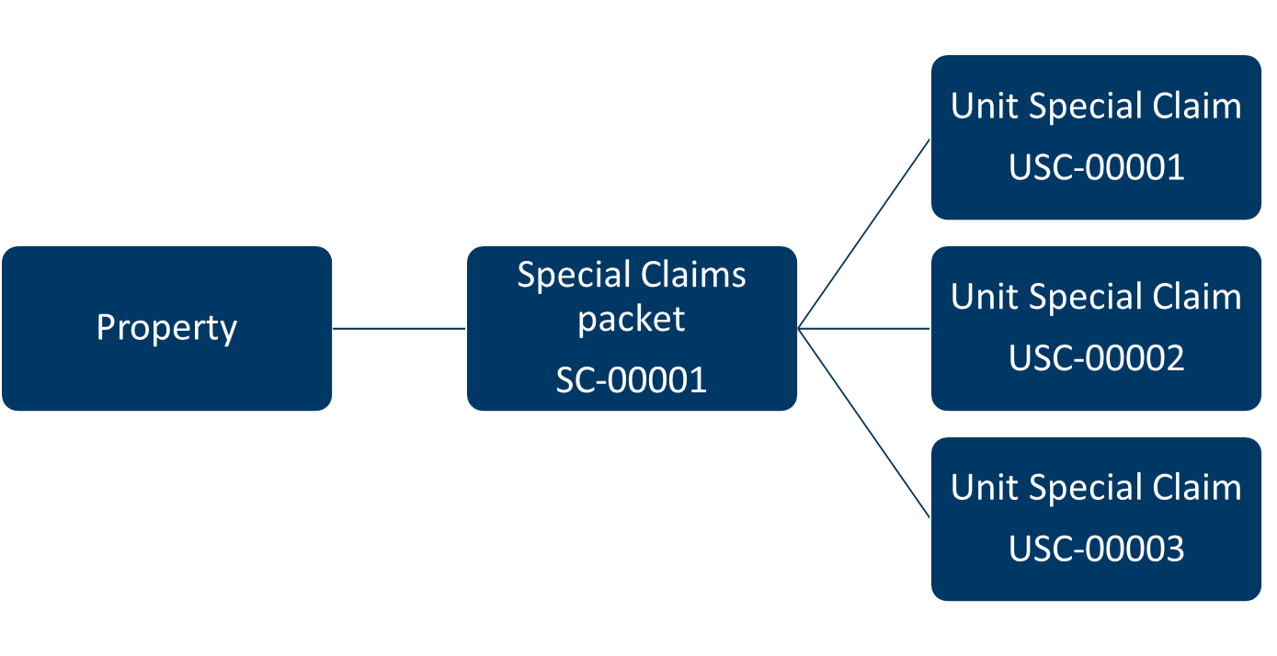

* The **Property** is the physical asset.
* The **Special Claims packet** is a collection of unit claims for a property for a given month. Submit all unit claims for a property at the same time in a single Special Claims packet. When a new Special Claims packet is created, the system will automatically assign it a unique packet ID.
* Each **Unit Special Claim** represents a unit within the property that has a Regular Vacancy or Unpaid Rent and/or Tenant Damages. The system will assign each Unit Special Claim a unique ID.

## Navigation Menu

The **Navigation menu** includes the following features:



1. **Home**. This is the default page after log in. Access links to Special Claims guidance, training, and resources. Portal resources are also available on this page.
2. **Property.** View all the properties in your portfolio. Don’t see the property you are looking for? To request access to a property, contact [mhfa.app@state.mn.us](mailto:mhfa.app@state.mn.us).
3. **Special Claims**. View all Special Claims packets created in the Portal, including the processing status and key dates. For more details, refer to the Check Claim Status section of this guide.
4. **Unit Special Claims**. View all Unit Special Claims in the Portal, including processing status. For more details, refer to the Check Unit Special Claim Status section of this guide.
5. **Search.** Use the search feature to locate properties, Special Claims, or Unit Special Claims.
6. **Notification bell.** If you have an in-application notification, click the **Bell** icon to view the message.
7. **User Profile.** Click your username to view more profile options.

## Access Properties

To submit a Special Claims packet, you will need to access the property record by following these steps:

* [Log in](https://mnhousing.my.site.com/MultifamilyPortal/login) to the Portal. Refer to our [Log In](https://www.mnhousing.gov/get/MHFA_238293) guide for details.
* On the home page, click the **Property icon** or select **Property** in the **Navigation menu** at the top of the page.
* On the new screen you will see the list of properties in your portfolio.
* Click the **name of the property** to navigate to the property record.

On the property record you will see:

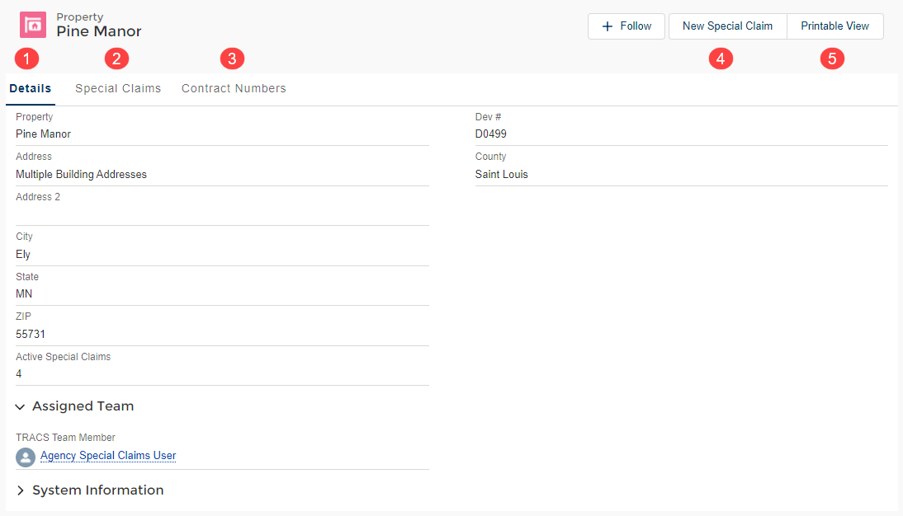

1. **Details tab**. This tab lists the property name, address, and number of active Special Claims.
2. **Special Claims tab.** This tab lists the Special Claims packets created for this property. It includes the claim status, number of Unit Special Claims, submission date, and date the packet was completed.
3. **Contract Numbers tab.** This tab lists all the contract numbers associated with the property and the assigned TRACS team member from Minnesota Housing.
4. **New Special Claim button.** Click the **New Special Claim** button to start a new Special Claims packet.
5. **Printable View button.** To print a snapshot of the property details, Special Claims packet statuses, and contract numbers, click the **Printable View** button.

## Create a Special Claims Packet

To create a Special Claims packet:

* Navigate to the property record and click the **New Special Claim** button in the upper right corner of the page. A pop-up window will appear.
* Begin typing the contract number in the **Contract Number** field. Select the appropriate number from the dropdown list when it appears.

**TIP:** Valid contract numbers start with MN46 followed by seven digits or MN39RDD followed by four digits.

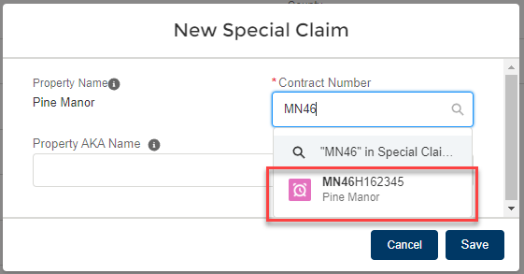

* Click the **Save** button.
* A message in green will appear confirming the Special Claims packet was created. Remain on the property record and navigate to the Special Claims packet you just created to continue working on it.
* Click the **Special Claims** tab.
* Click the Special Claims packet record you just created in the **Packet ID** column

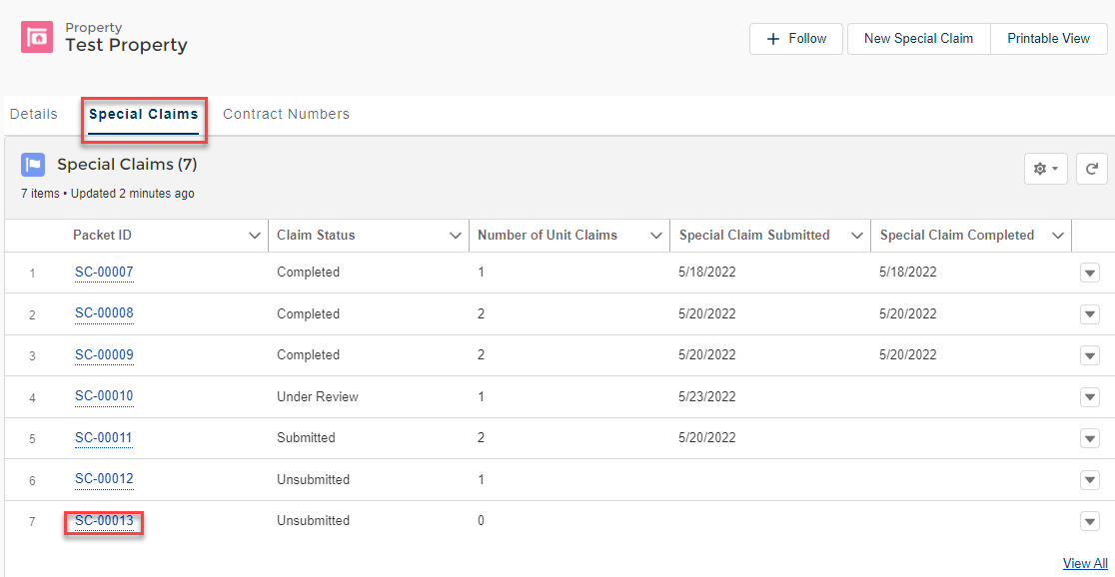

On the Special Claims record you will see:

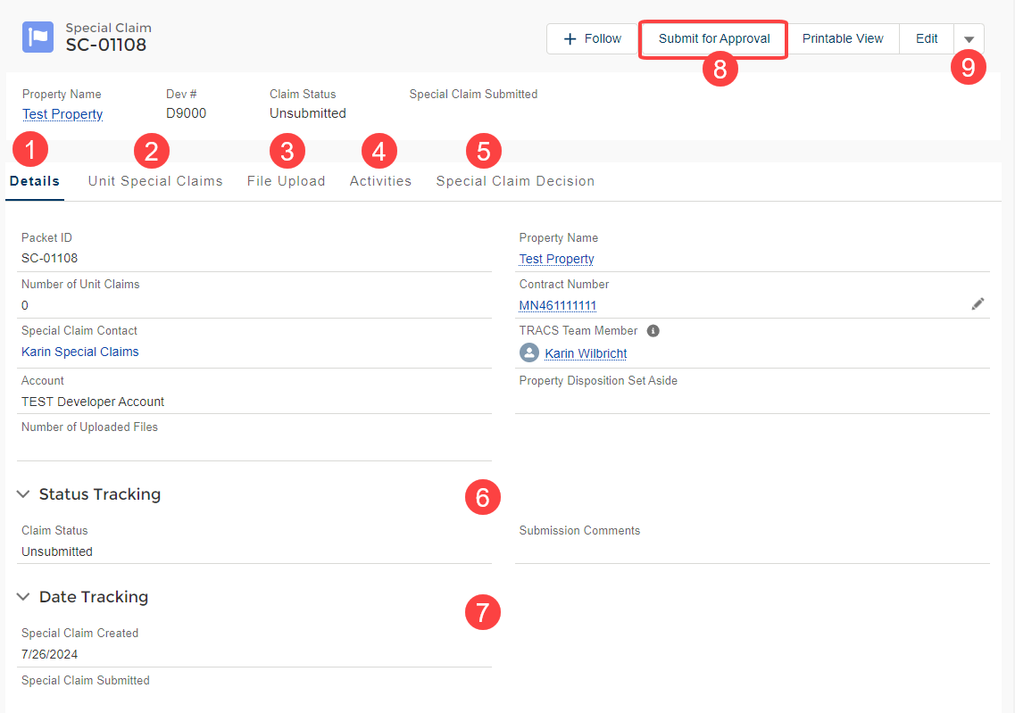

1. **Details tab.** This tab includes basic information about the Special Claims packet including the packet ID, number of Unit Special Claims, and the contact person for the claim.
2. **Unit Special Claims tab.** This tab lists the Unit Special Claims associated with the packet including the claim type (Regular Vacancy or Unpaid Rent and Tenant Damages), Unit Special Claims status and the 180-day submission deadline.

**TIP:** You can create new Unit Special Claims from this tab. Refer to the Create a Unit Special Claim section of this guide for details.

1. **File Upload tab.** Upload HUD-52670-A Part 2 (Special Claims Schedule) to this tab. For more details on how to upload files, refer to the Upload Files section of this guide.
2. **Activities tab.** View notifications sent by Minnesota Housing regarding the Special Claims packet.
3. **Special Claim Decision.** View Special Claims decision files including signed HUD-56261-A and HUD-52671-C forms for all claims within the Special Claims packet.
4. **Status Tracking.** Check the status of the Special Claims packet. Statuses include Unsubmitted, Submitted, Under Review, and Completed.
5. **Date Tracking.** View the date the Special Claims packet was created, submitted, and completed.
6. **Submit for Approval button**. Use the Submit for Approval button to send your Special Claims packet to Minnesota Housing for review. Refer to the Submit a Special Claims Packet section of this guide for more details.
7. **Other buttons.** Click the arrow dropdown button next to the buttons to see other available options including **Delete**. The delete button is available until the claim is submitted.

**TIP:** After you create a Special Claims packet, you can return to it at any time by going to the **Special Claims** tab in the **Navigation menu**. For more details, refer to the Check a Claim Status section of this guide.

## Create a Unit Special Claim

Within a Special Claim packet, you can add one or more Unit Special Claims. Unit Special Claims are used to submit documentation for units with either Regular Vacancy or Unpaid Rent and Tenant Damages (Unpaid Rent / Damage Claims). For more information refer to Minnesota Housing’s [website](https://mnhousing.gov/rental-housing/property-managers/section-8---811-contracts.html).

To create a Unit Special Claim while on the Special Claims packet record:

* Click the **Unit Special Claims** tab.
* Click the **New** button on the right side of the page.

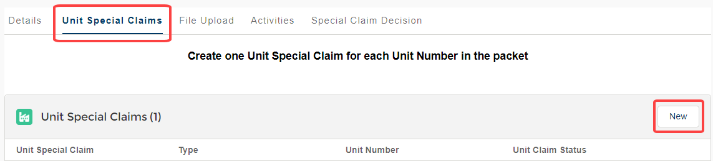

* A pop-up window will appear and ask you to select either **Regular Vacancy** or **Unpaid Rent and Tenant Damages** record type.
* Click the **Next** button.
* You will be prompted to respond to different questions based on the record type selected. You must complete all required fields.

**TIP:** The **Unit Ready Date** cannot be greater than 180 days old. If you missed the 180-day submission deadline, you will receive an error message.

* Click the **Save** button. The Unit Special Claim will appear in the list with a default status of **Documents Required**. To continue working on this Unit Special Claim, refer to the Edit or Delete a Unit Special Claim, Upload Files and Manage Your Checklist sections of this guide for next steps.
* Create additional Unit Special Claims as needed by repeating the steps outlined above

Prior to submitting the Special Claim packet, on the Unit Special Claim record you will see:

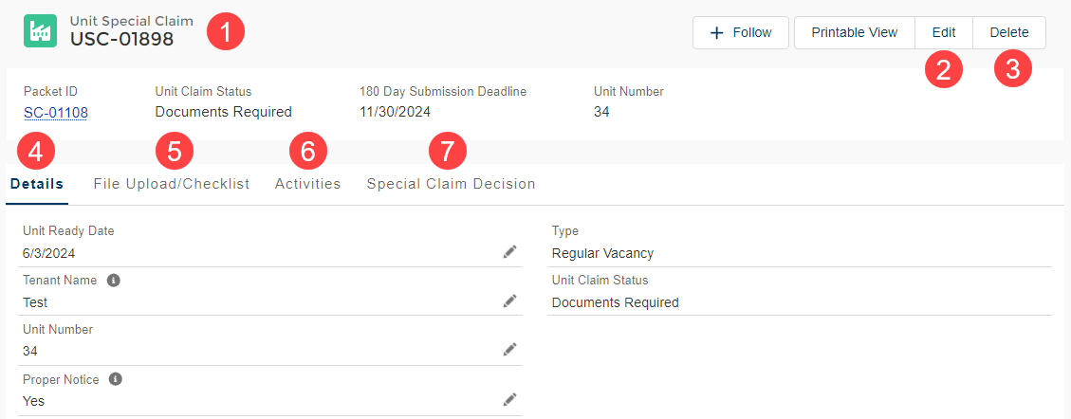

1. **Unit Special Claim header**. The header includes the Packet ID, Unit Claim Status, 180 Day Submission Deadline, and Unit Number
2. **Edit button**. Click the Edit button to modify the Unit Special Claim prior to submission. Refer to Edit or Delete a Unit Special Claim section of this guide.
3. **Delete button**. Click the Delete button to modify the Unit Special Claim prior to submission. Refer to Edit or Delete a Unit Special Claim section of this guide.
4. **Details tab.** This name includes the information provided about the Unit Special Claim including the Unit Ready Date, claim type (Regular Vacancy or Unpaid Rent and Tenant Damages) and the Unit Claim Status.
5. **File Upload/Checklist tab.** The documents required to submit a Unit Special Claim are identified in the checklist on the File Upload/Checklist tab. Files can be uploaded directly to this tab. Refer to the Upload Files and Manage Your Checklist sections of this guide.
6. **Activities tab.** View notifications sent by Minnesota Housing regarding the Unit Special Claim.
7. **Special Claims Decisions.** View Special Claims decision files such as the signed HUD-56261-A and HUD-52671-C forms for the Unit Special Claim.

Table 1: Unit Special Claim Status and Description

| Status | Description |
| --- | --- |
| Documents Required | Default status. Files need to be uploaded to the File Upload/Checklist tab and/or boxes on the checklist are unchecked. |
| Ready for Submission | Files are uploaded to the File Upload/Checklist and all boxes on the checklist are checked. |
| Submitted | The Unit Special Claim was submitted. Minnesota Housing has not begun reviewing the claim. |
| Under Review | Minnesota Housing has begun reviewing the Unit Special Claim. |
| Pending | Additional information is needed from Minnesota Housing to continue processing the claim. Refer to the Modify and Resubmit a Pending Unit Special Claim section of this guide. |
| Resubmitted | The Unit Special Claim was resubmitted after additional information was provided at Minnesota Housing’s request. |
| Approved | The Unit Special Claim was approved. |
| Adjusted | The Unit Special Claim was adjusted. |
| Past Due Denied | If you do not provide the requested information by the Information Due Date, the Unit Special Claims Status will automatically switch to Past Due Denied. Your claim will be denied. |
| Denied | The Unit Special Claim was denied. |

## Edit or Delete a Special Claim

You can edit and/or delete Unit Special Claims prior to submitting a Special Claims packet.

### Edit a Special Claim

There are two ways to edit a Unit Special Claim:

#### Use the Action Menu

* Navigate to the Special Claims packet record.
* Click the Unit Special Claims tab.
* Click the down arrow to the right of the Unit Special Claim you wish to edit.

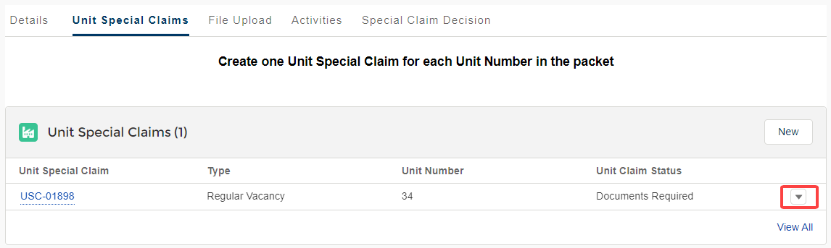

* Select Edit from the Action menu options.
* Modify the fields as needed and click Save**.**

#### Click the Pencil Icon

* Navigate to the Unit Special Claims.
* Click the Pencil icon to the right of the field you want to edit.

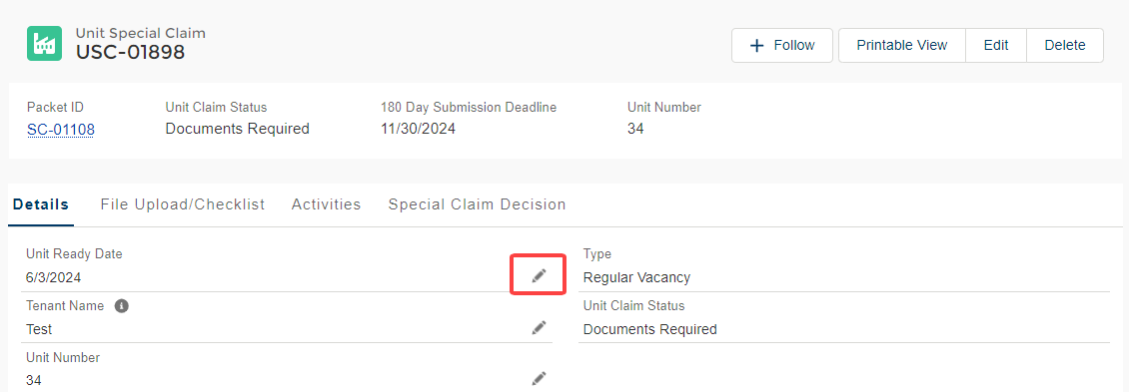

* Modify the fields as needed and click **Save.**

**TIP:** You cannot change the Unit Special Claim Type or the Checklist Type after the record is created. If you need to select a different type, delete the record, and create a new Unit Special Claim record.

### Delete a Special Claim

To delete a Unit Special Claim:

* Navigate to the Special Claims packet record.
* Click the **Unit Special Claims** tab.
* Click the **down arrow** to the right of the Unit Special Claim you wish to edit.



* Select **Delete** from the **Action menu** options.
* A pop-up will appear and ask you, “Are you sure you want to delete this Unit Special Claim?” Click **Delete** to proceed.

## Upload Files

Files can be uploaded to the Special Claims packet and individual Unit Special Claims. On the Special Claims packet, upload HUD-52670-A Part 2 (Special Claims Schedule) to the **File Uploads** tab. On an individual Unit Special Claim, upload the checklist items listed on the **File Uploads/Checklist** tab. Refer to the Manage your Checklist section of this guide for more details about the checklist feature.

There are two ways to upload files:

### Drag and Drop

* Navigate to the file stored on your computer.
* Click the file and drag it into the Files section. A blue box will appear around the files section and ‘Drop Files’ will appear on the screen.

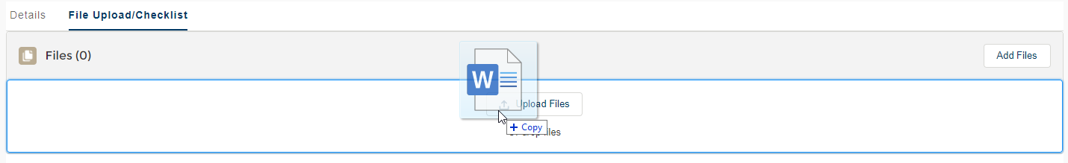

* Release the file to drop it into the Files section

### Use ‘Add Files’ Button

* Click **Add Files** within the Files section.

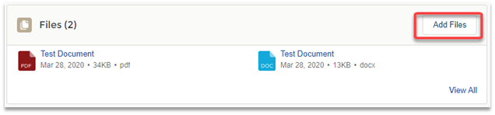

* Click the **Upload Files** button to select the file.

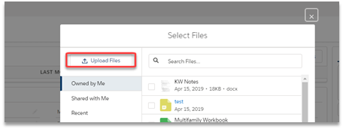

* Locate the file on your computer and select Open. Once the file has uploaded, select Done.

**TIP:** Keep the following in mind when working with files:

* You cannot upload additional files to the Special Claims packet or Unit Special Claims once the Special Claims packet is submitted unless additional information is requested from Minnesota Housing. Minnesota Housing will set the Unit Special Claims status to **Pending** to allow additional uploads.
* You can drag and drop more than one file at a time.
* There are no limits to the number of files you may upload.
* The maximum file size is 2 GB.
* File names cannot exceed 80 characters (including spaces).

## Manage Your Checklist

The documents required to submit a Unit Special Claim are identified in the checklist on the **File Upload/Checklist** tab of a Unit Special Claim. The checklist includes the following features:

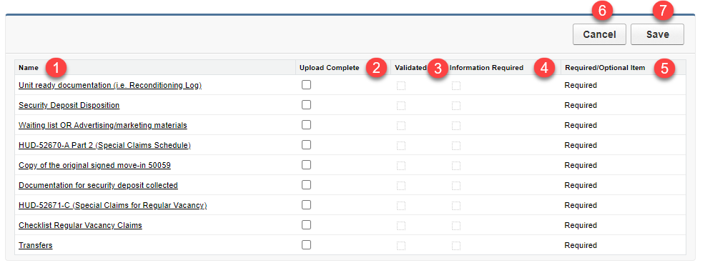

1. **Name.** This column lists the checklist item names. If you click a checklist item name, you will be brought to another screen that describes the requirements in more detail.
2. **Upload Complete**. These fields can be used to track your progress providing the required supporting documentation. All boxes must be checked before the claim can be submitted.
3. **Validated.** Minnesota Housing will use this column to indicate that the checklist item has been reviewed and no additional information is required.
4. **Information Required.** Minnesota Housing will use this column to indicate if additional information is required for the checklist item(s).
5. **Required/Optional Items.** This field indicates if the checklist item is required or optional.
6. **Cancel button.** If you modify the checklist but do not want to save your changes, click **Cancel**.
7. **Save button.** Click **Save** to save changes made to the checklist.

To manage your checklist:

* After you have uploaded the appropriate supporting documents to the **Files** section, check the box(es) in the **Upload Complete** column.

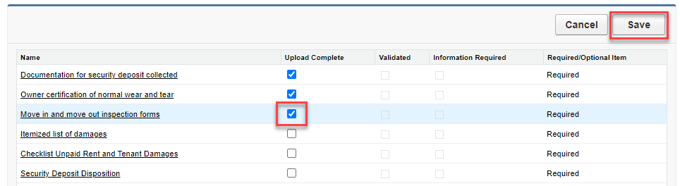

* Click Save.

**TIP:** You must check all the boxes for required items before you can submit a Unit Special Claim. Once all boxes for required items are checked and you click **Save**, the Unit Special Claim Status for the Unit Special Claim you are working on will switch to **Ready for Submission**.

## Submit a Special Claims Packet

To submit a Special Claims packet:

* Navigate to the Special Claims packet.
* Click the Unit Special Claims tab to confirm all Unit Special Claims have a status of **Ready for Submission**.
* Click the **Submit for Approval** button in the upper right corner of the screen.



* The system will check for common errors. If an error is found, a message will appear indicating you need to modify the packet or related Unit Special Claims prior to submission.
* If an error appears, correct the error, and click **Submit for Approval** again. Refer to the Sample Errors and Corrective Actions table for more details.
* If no errors are found, an optional **Submit Comments** field will appear. Enter comments if desired and click **Next.**
* A message will display stating the Specials Claims packet was submitted successfully. Click the **Finish** button.

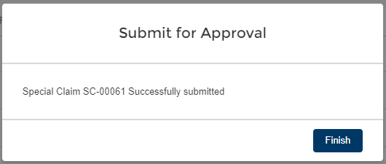

Table 2: Sample Errors and Corrective Actions

| Error | Action to Take |
| --- | --- |
| You cannot submit a Special Claim with no Unit Special Claims. Add a Unit Special Claim. | Add a Unit Special Claim to the Special Claims packet.Refer to the Create a Unit Special Claim section of this guide. |
| You cannot create a Unit Special Claim with a Unit Ready Date more than 180 days in the past. | Correct the Unit Ready Date for this claim or delete it from the packet. Refer to the Edit or Delete a Unit Special Claim section of this guide. |
| One or more Unit Special Claims in this Special Claim do not have MI/UT submitted to TRACS. MI/UT must be submitted to TRACS before submitting a Unit Special Claim. | Navigate to the impacted Unit Special Claim and update the MIT/UAT Submitted to TRACS field to Yes or Not Re-Rented prior to submission. Refer to the Edit or Delete a Unit Special Claim section of this guide. |
| One or more Unit Special Claims in this Special Claim is missing required documents. | Navigate to the impacted Unit Special Claim and upload the documents and/or update the checklist to note all items were provided. Refer to the Upload Files section of this guide. |
| A claim packet cannot be submitted without HUD-52670-A Part 2 (Special Claims Schedule). | On the Special Claims packet, upload the HUD-52670-A Part 2 (Special Claims Schedule) to the File Uploads tab. Refer to the Upload Files section of this guide. |

Once the Special Claims packet is submitted, additional fields will become available on the Unit Special Claims page layout.

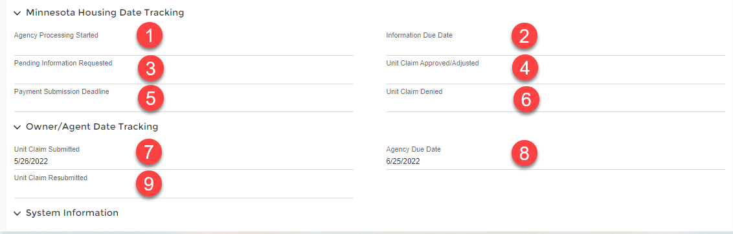

Fields include:

1. **Agency Processing Started.** Populates when Minnesota Housing changes the Unit Special Claim status to Under Review
2. **Information Due Date.** Populates with a deadline for customers when Minnesota Housing changes the Unit Special Claim status to Pending. The date is the lesser of 30 days from the Pending Information Requested date or the 180-day submission deadline.
3. **Pending Information Requested.** Populates with the date when Minnesota Housing changes the Unit Special Claim status to Pending.
4. **Unit Special Claim Approved/Adjusted.** Populates with the date the Unit Special Claim is approved or adjusted.
5. **Payment Submission Deadline.** Populates with the 90-day deadline from the date the Unit Special Claim status was updated to Approved or Adjusted. Customers must add the Approved/Adjusted claim to their voucher by the deadline.
6. **Unit Special Claim Denied.** Populates with the date the Unit Special Claim is denied.
7. **Unit Special Claim Submitted.** Populates with the date the Special Claim packet was submitted.
8. **Agency Due Date.** The date that Minnesota Housing needs to act on the Unit Special Claim.
9. **Unit Special Claim Resubmitted.** Populates with the date a Unit Special Claim is resubmitted if Minnesota Housing requests additional information.

## Modify and Resubmit a Pending Unit Special Claim

If Minnesota Housing requires additional information to process your Unit Special Claim(s), you will receive an email regarding a pending Unit Special Claim. The action(s) you need to take and the information submission due date will be outlined in the body of the email. **If you do not provide the requested information by the Information Due Date, the Unit Special Claims Status will automatically switch to Past Due Denied.** You will receive an error message if you try to resubmit after the information due date. Your claim will automatically be denied.

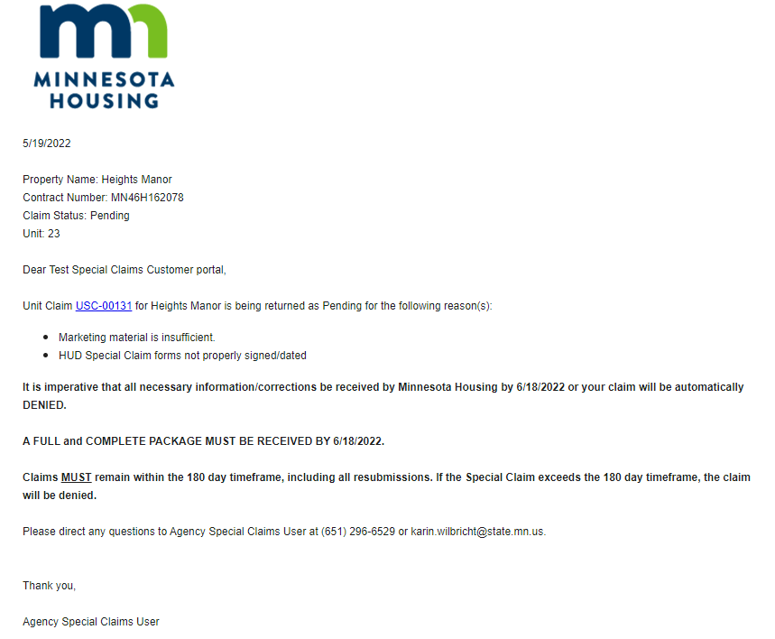

**TIP:** You can click the Unit Special Claim ID (USC-#####) in the body of the email to go to the record or enter the Unit Special Claim ID in the search bar on the **Navigation** **menu**.

To modify and resubmit a Unit Special Claim:

* Navigate to the Unit Special Claim that you need to modify. The Unit Special Claim number is identified in the email.
* Click the **File Upload/Checklist** tab. If additional information is required, you will see a checkmark in the **Information Required** field to the right of the checklist item.
* Upload additional files as needed. Refer to the Upload Files section of this guide.
* After you have uploaded the appropriate supporting documents to the **Files** section, check the box(es) in the **Upload Complete** column.

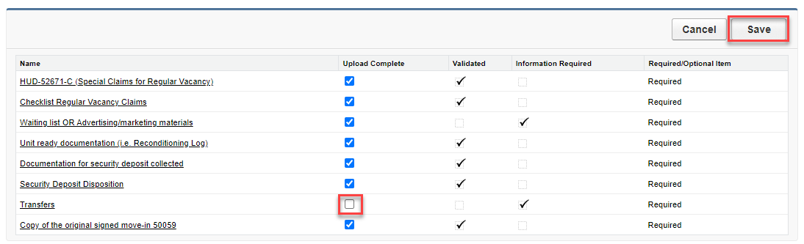

* Click **Save**.

**TIP:** You must check all the boxes before you can resubmit a Unit Special Claim. If you attempt to resubmit a Unit Special Claim without updating the checklist, you will receive an error message that states, “All required documents have not been uploaded to this Unit Special Claim. Before resubmitting, upload the necessary documents and complete the checkboxes.”

* Click the **Resubmit** button in the upper right corner of the screen

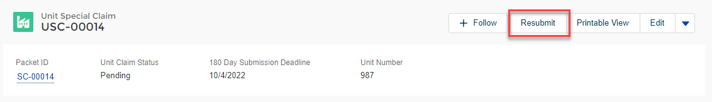

## Approved, Adjusted, or Denied Unit Special Claims Notifications

After Minnesota Housing has completed its review of a Unit Special Claim, you will receive an email informing you whether the Unit Special Claim was approved, adjusted, or denied.

### Approved or Adjusted Unit Special Claims

If the Unit Special Claim is approved or adjusted, the email will include the Special Claim HUD ID and the deadline to submit for payment to HUD.

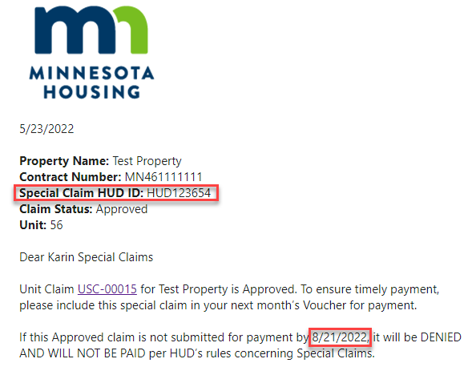

The Special Claim Decision documents are available in the Portal using the Unit Claim ID link within the notification.

To view and download the Special Claim Decision:

* Click on the Unit Claim ID within the body of the notification. The link will bring you to the Special Claims Decisions Files
* Click on the file icon to open a file preview.

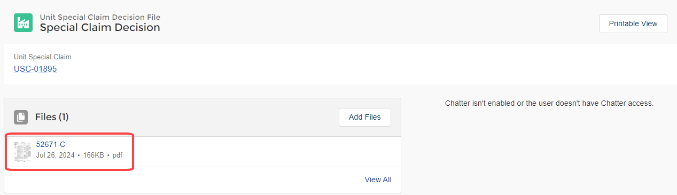

* Click download to save the file locally. Click the X icon to close the file preview.

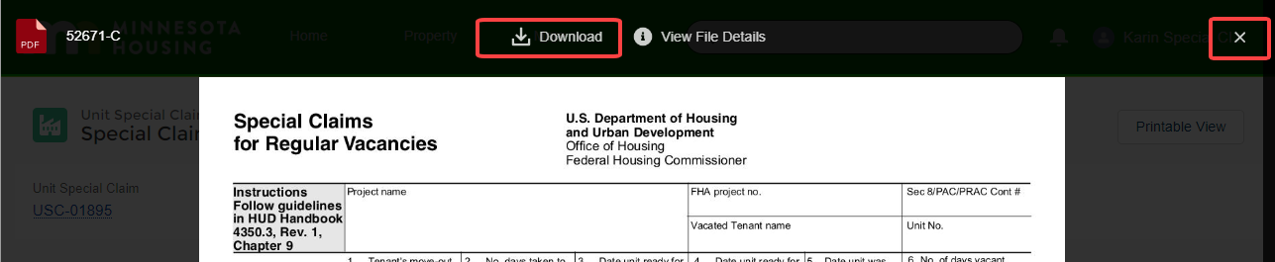

### Denied Unit Special Claims

If the Unit Special Claim was denied, the email will include the reason for denial and how to appeal the decision.

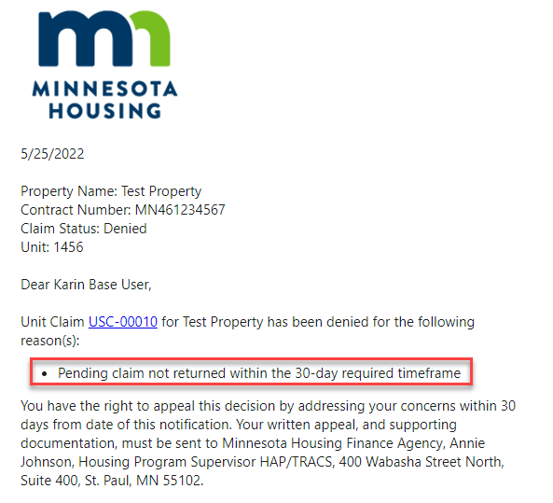

To view and download the Special Claim Decision:

* Click on the Unit Claim ID within the body of the notification. The link will bring you to the Special Claims Decisions Files
* Click on the file icon to open a file preview.



* Click download to save the file locally. Click the X icon to close the file preview.



## View Notifications

A copy of the emails sent by Minnesota Housing are available in the Portal.

### Access Special Claims Packet Notifications

Notifications regarding a Special Claims packet or multiple Unit Special Claims within a packet are stored on the Activities tab on the Special Claims packet record. To view a notification:

* Navigate to the **Special Claims packet**.
* Click the **Activities** tab.
* Click on the notification subject to view the message.

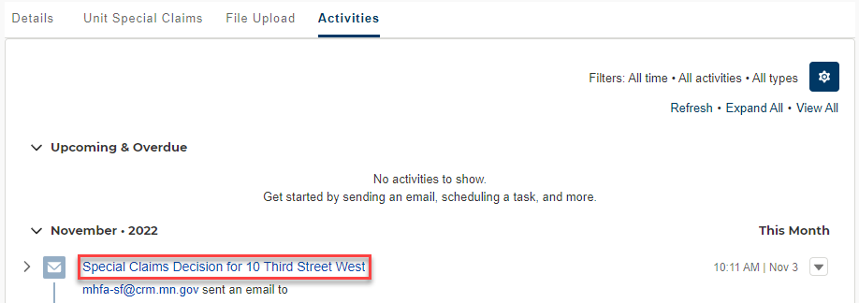

### Access Unit Special Claims Notifications

Notifications regarding individual Unit Special Claims are stored on the Activities tab on the Unit Special Claim record. To view a notification:

* Navigate to the **Unit Special Claim**.
* Click the **Activities** tab.
* Click on the notification subject to view the message.

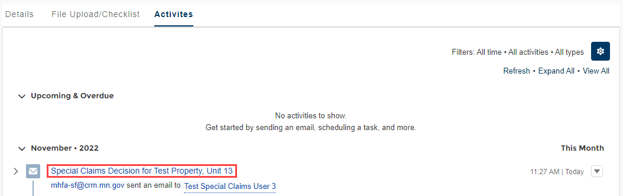

## Check Claim Status

Once you create a Special Claims packet (even if not yet submitted), you can return to it at any time by going to the Special Claims tab in the **Navigation** **menu**. From the Special Claims tab, you can view the Special Claims packet status for all properties in your portfolio.

On this screen you can:

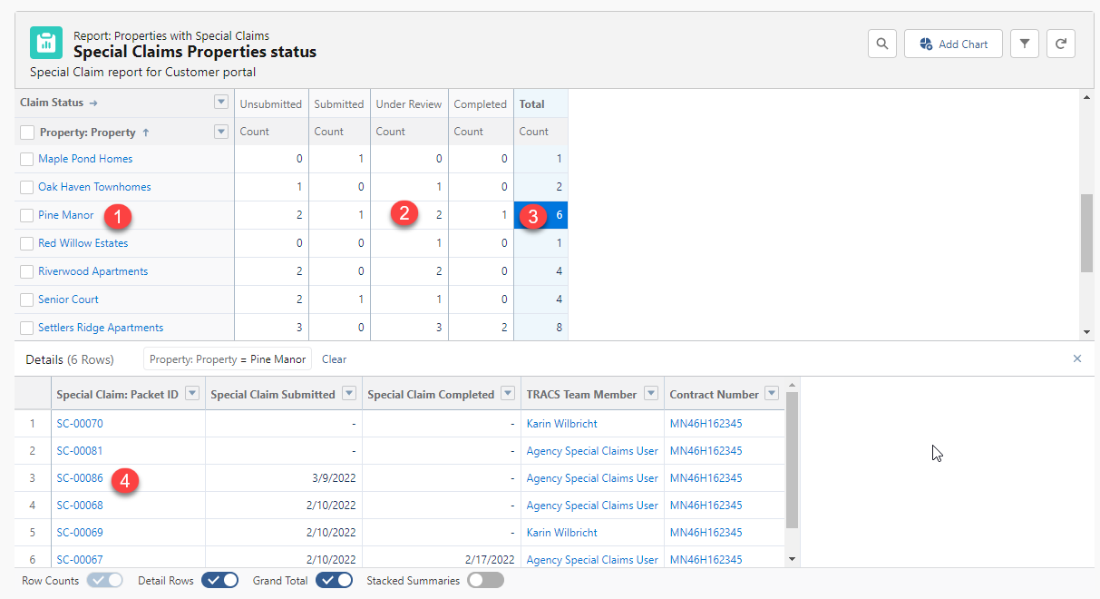

1. Click the name of a property in the upper grid to go to the property record.
2. Click a **Status** cell for a specific property to view all Special Claims packets in this status. The list of Special Claims packets will appear in the details section (lower grid) of the report.

Table 3: Special Claim Status and Description

| Status | Description |
| --- | --- |
| Unsubmitted | Unsubmitted Special Claims packets. |
| Submitted | Submitted Special Claims packets that have not been reviewed yet by Minnesota Housing. |
| Under Review | Submitted Special Claims packets that are under review by Minnesota Housing. |
| Completed | Once all Unit Special Claims within a packet have a status of approved, adjusted, or denied, the Special Claims packet status will update to Completed. |

1. Click the **Total** cell for a given property to view all Special Claims packets associated with the property. The list of Special Claims packets will appear in the details section of the report.
2. Click the Special Claims packet **ID link** in the Special Claims (lower) grid to go to the record.

## Check Unit Special Claim Status

Once you create a Unit Special Claim, you can return to it at any time by going to the Unit Special Claims tab in the **Navigation** **menu**. From the Unit Special Claims tab, you can view the Unit Special Claim status for all properties in your portfolio.

* The list view defaults to Recently Viewed. To change the list view, click the **down arrow** next to the list view name and select a view from the list.

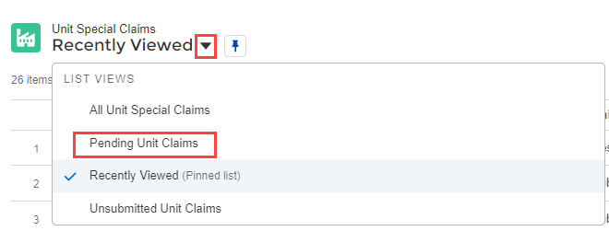

* + Select **All Unit Claims** to see all the Unit Special Claims in the Portal.
  + Select **Pending Unit Claims** to see all Unit Special Claims with a Pending status. These claims require action from you.
  + Select **Unsubmitted Unit Claims** to see all Unit Special Claims with a Documents Required or Ready for Submission status. These claims require action from you.
* Click the **Unit Special Claim ID** to view or modify the unit claim.

**TIP:** To pin a list view, click the Pin icon Pin icon tilted to the right.. When you select that object, the pinned list view loads as the default list view. A pinned icon Vertical pin iconindicates a pinned list. To pin a different list, select a different list view and pin it instead. Learn more about working with List Views [here](https://trailhead.salesforce.com/en/content/learn/modules/list-views-quick-look/get-to-know-list-views).

## System Support

For system support, contact [mhfa.app@state.mn.us](mailto:mhfa.app@state.mn.us).

For questions regarding your Special Claims submissions, contact your assigned TRACS team member.