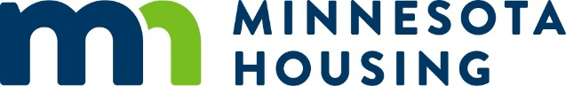

Housing Opportunities for Persons With HIV/AIDS (HOPWA)
Project Sponsor Form
Version: 1.00
Effective Date: 09/25/2023
- Information of person completing this form:
  - Name:
  - Title:
  - Email address:
  - Date of form completion:
- Is your organization registered in SAM.gov? Note: registration in SAM.gov is required to receive federal funds under this award.
Yes No
- What is the name of your organization, as registered in SAM.gov?
- What is your organization’s Universal Entity Identification (UEI) number? Note: an active UEI is required to receive federal funds under this award
- What is the total dollar amount of federal funds from all sources your organization expects to spend this fiscal year? If over $750,000, please attach your organization’s most recent single audit report. If under $750,000, please attach your organization’s most recent yearly external audit report.
- What is the beginning date of your organization’s fiscal year?
- Is anyone at your organization currently listed on the HUD Limited Denial of Participation List, either for HOPWA funds or any other HUD funding?
Yes No
- Has your organization or anyone at your organization ever been suspended or debarred from working with, or receiving contracts or funding from the federal government?
Yes No
Return this form and attachments to: MHFA.Grants@state.mn.us

